Supplementary Materials

Supplementary Table 1: Thermal Profile used for PCR.

Steps | Cycles | Temperature | Duration
Initial Denaturation | 1 | 94 ^{O}C | 5 minutes
Denaturation | 45 | 94 ^{O}C | 30 sec
Annealing | 45 | 55 ^{O}C (A genome primers)- 60^{O}C (B genome primers) | 30 sec
Extension | 45 | 72 ^{O}C | 1 minute
Final Extension | 1 | 72 ^{O}C | 7-10 minutes

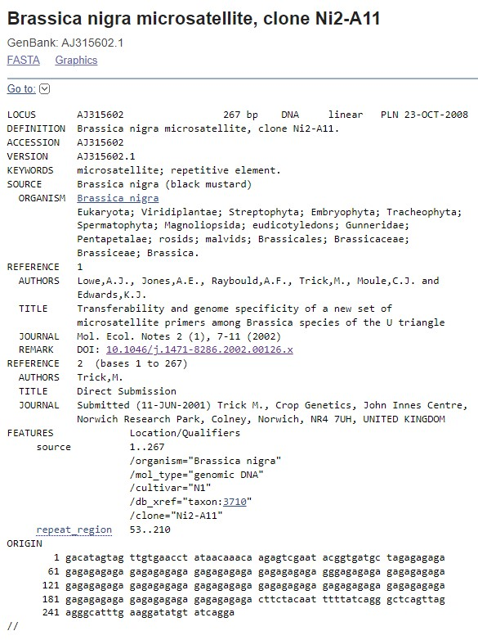
Supplementary Figure 1. Screenshot of NCBI page showing clone sequence of Ni2-A11.

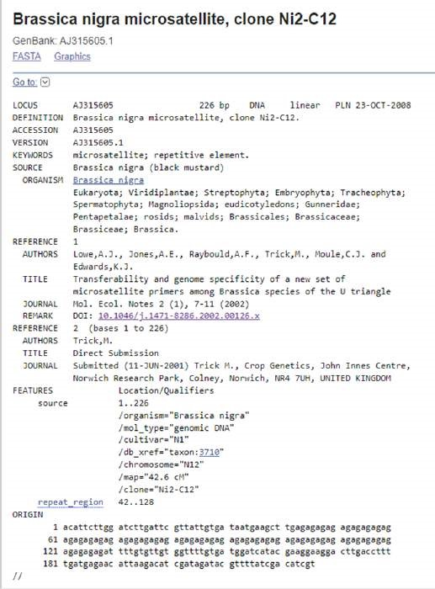

Supplementary Figure 2. Screenshot of NCBI page showing clone sequence of Ni2-C12.

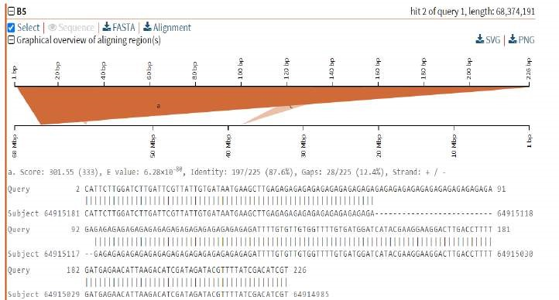

Supplementary Figure 3. Blast hit of Ni2-C12 to chromosome B5 of B. nigra at 64.9 Mb.

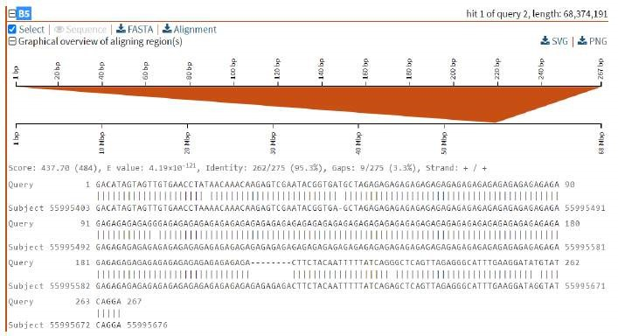

Supplementary Figure 4. Blast hit of Ni2-A11 to chromosome B5 of B. nigra at 55.9 Mb

